**Mongodb task**

**Day-2**

Creating DB  
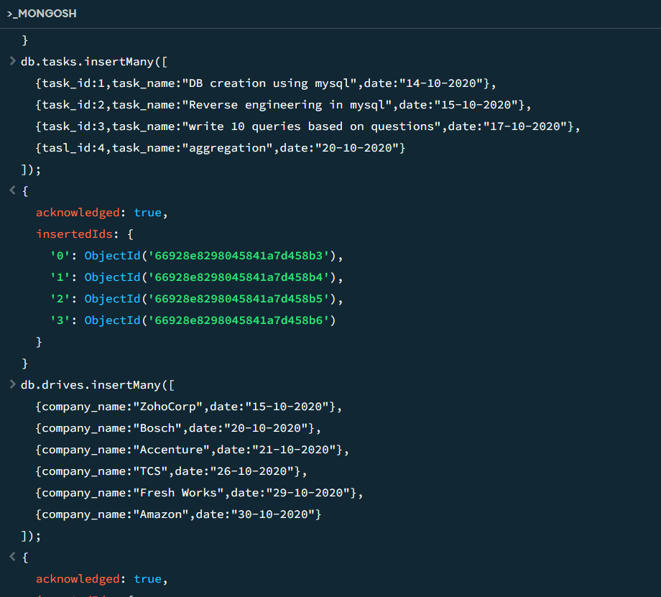

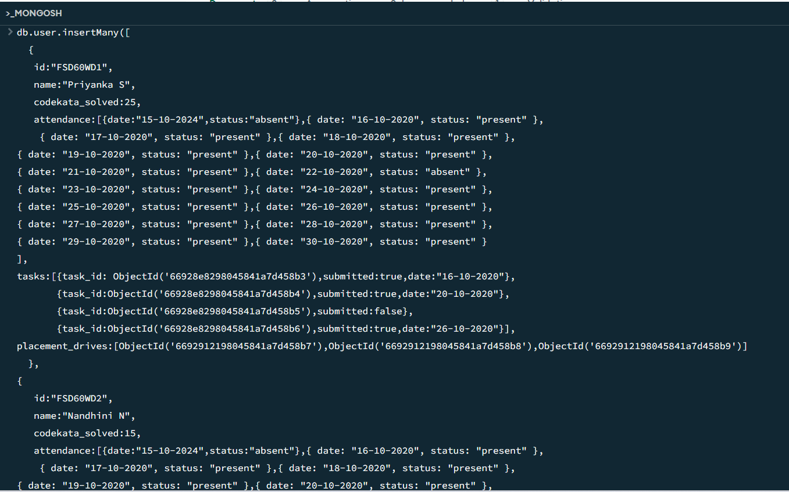

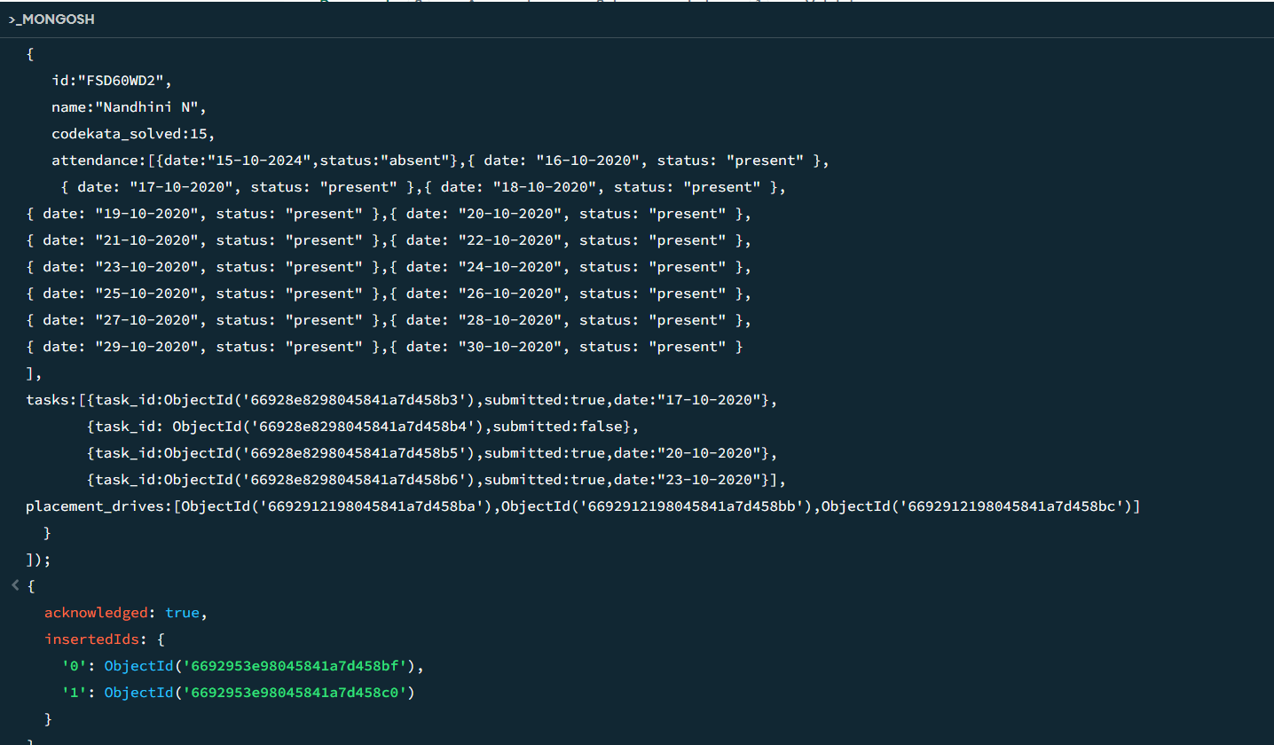

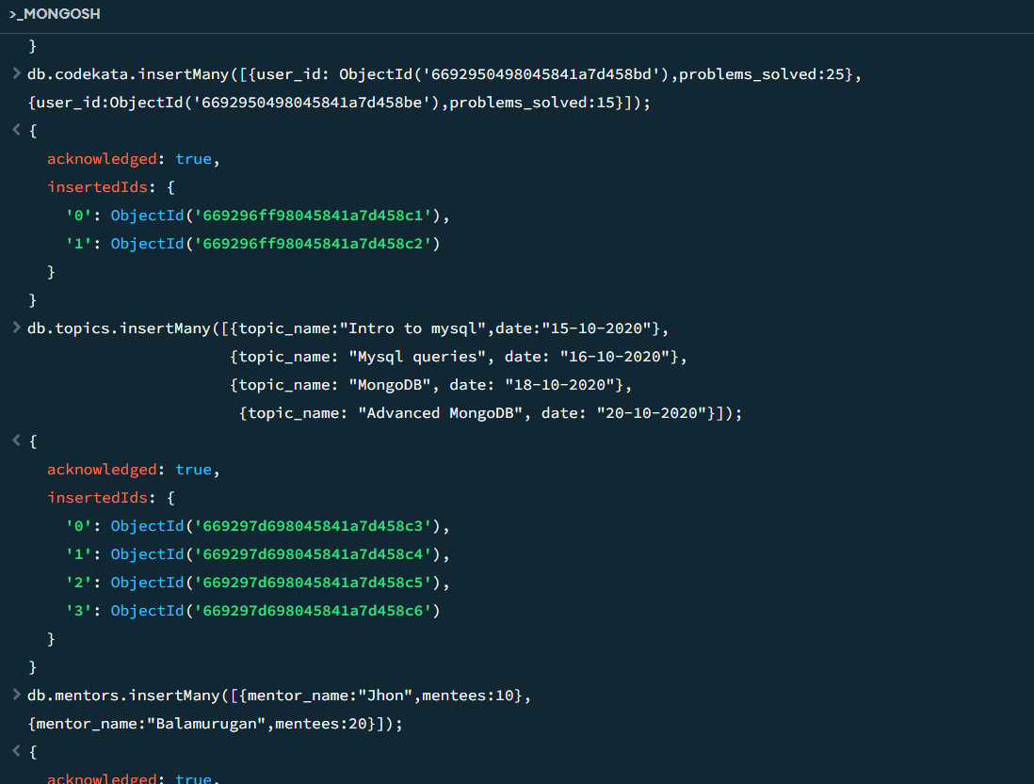

1. Find all the topics and tasks which are thought in the month of October

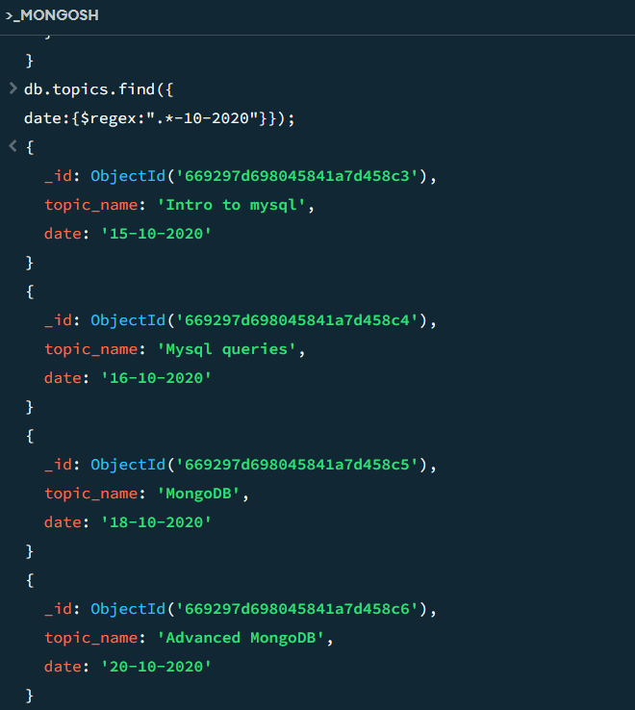

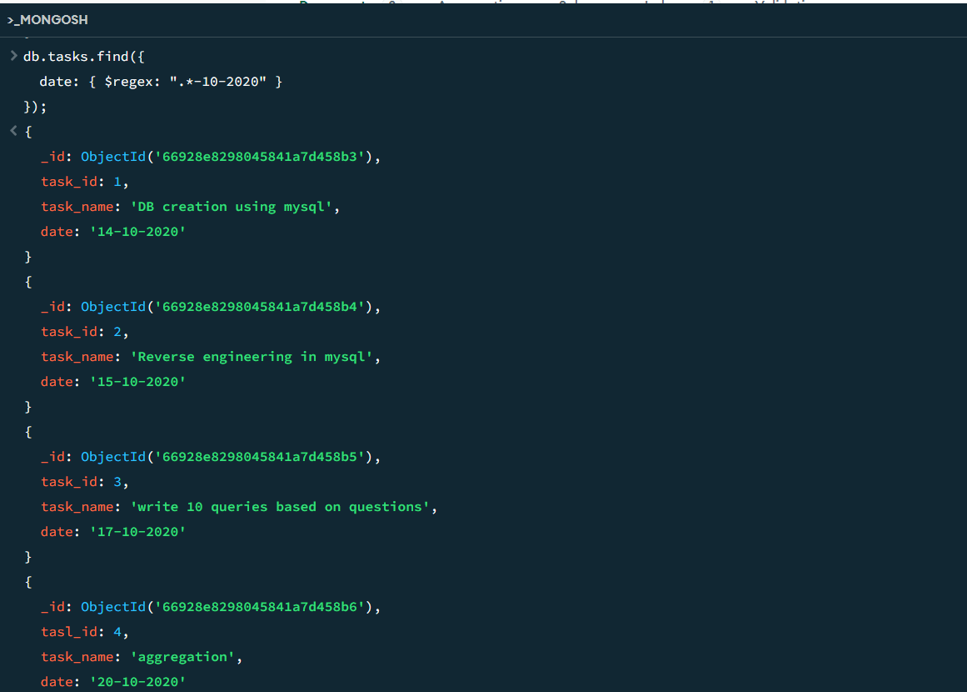

1. Find all the company drives which appeared between 15 oct-2020 and 31-oct-2020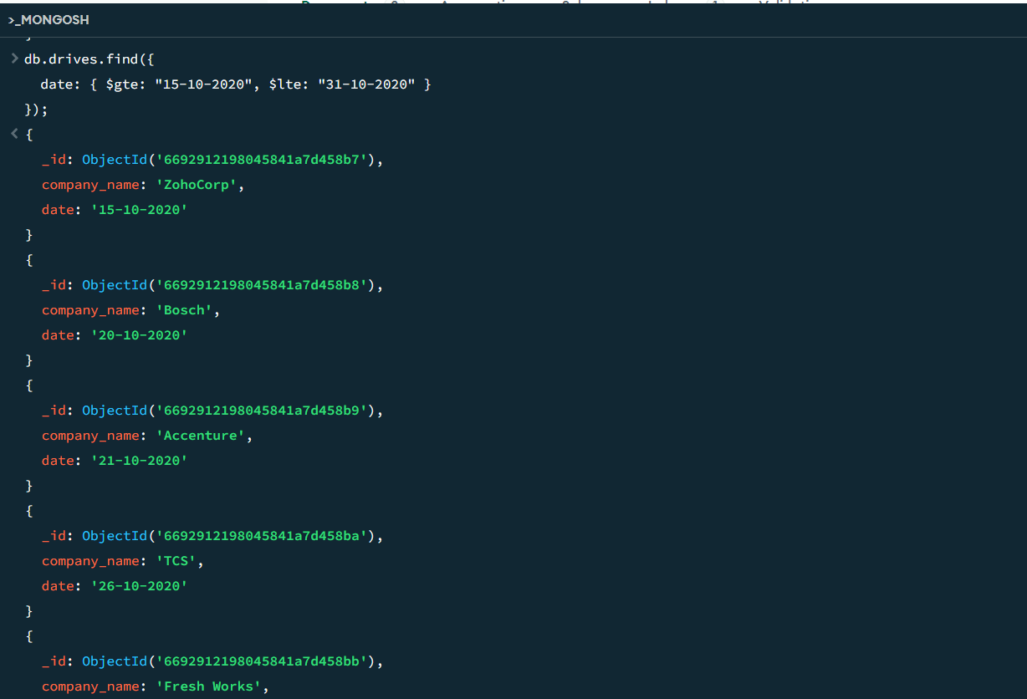
2. Find all the company drives and students who are appeared for the placement.

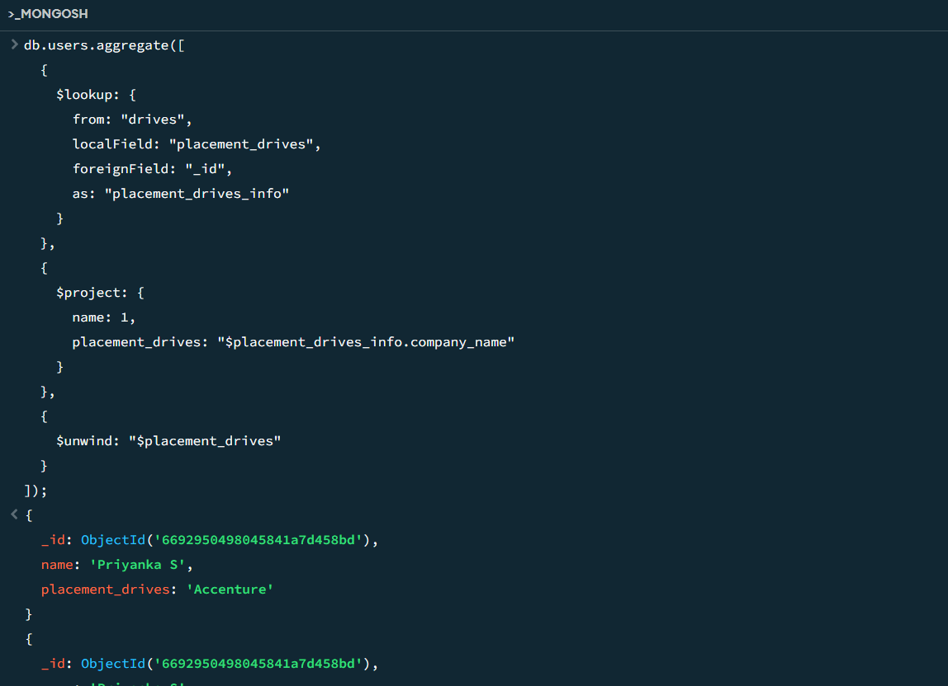

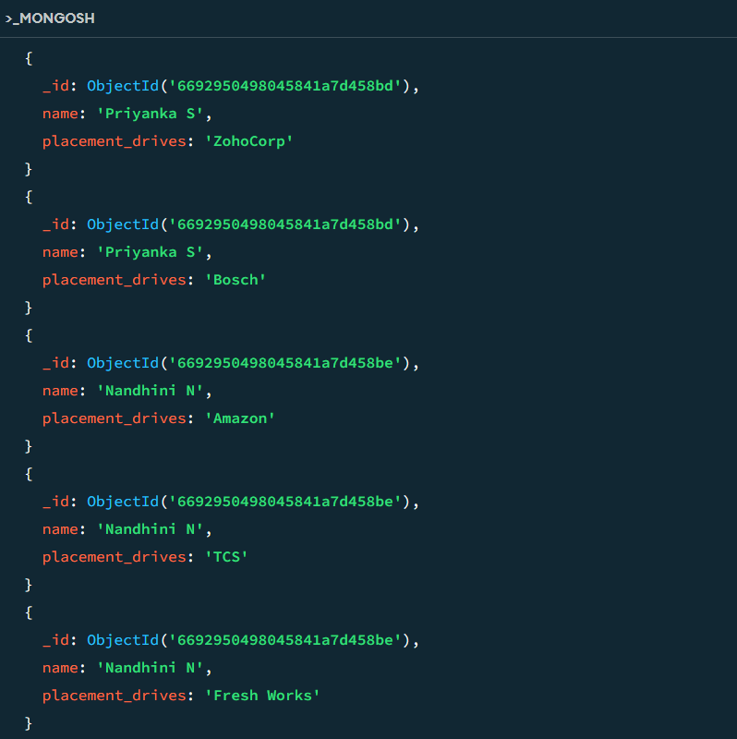

1. Find the number of problems solved by the user in codekata

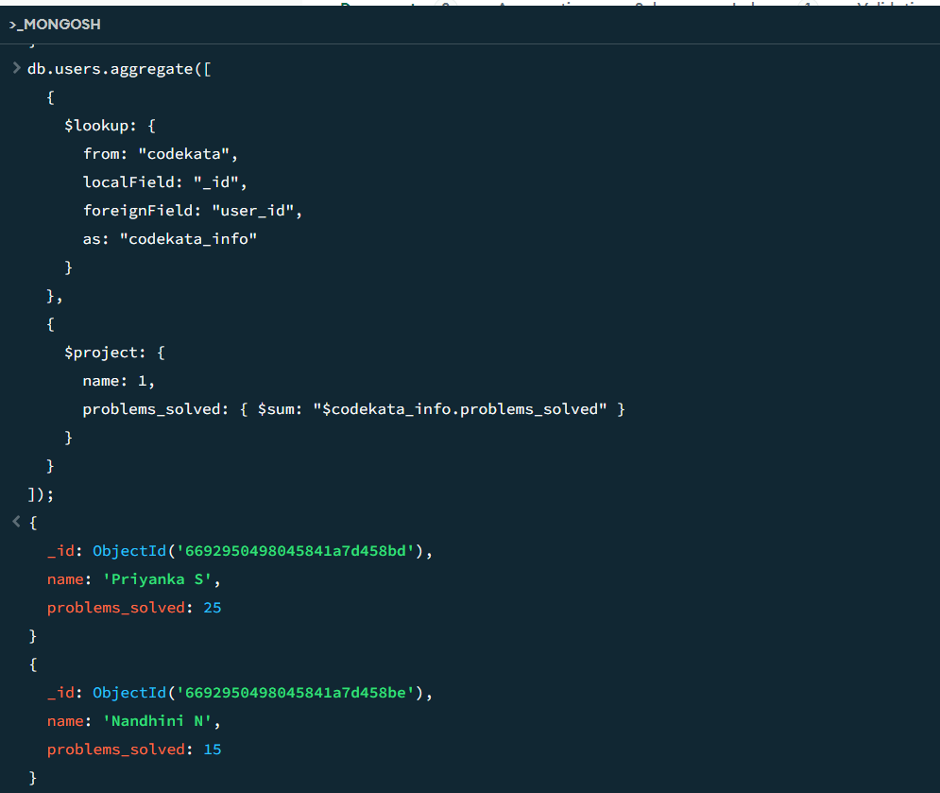

1. Find all the mentors with who has the mentee's count more than 15

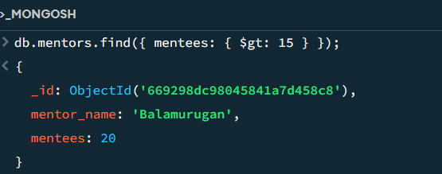

1. Find the number of users who are absent and task is not submitted  between 15 oct-2020 and 31-oct-2020

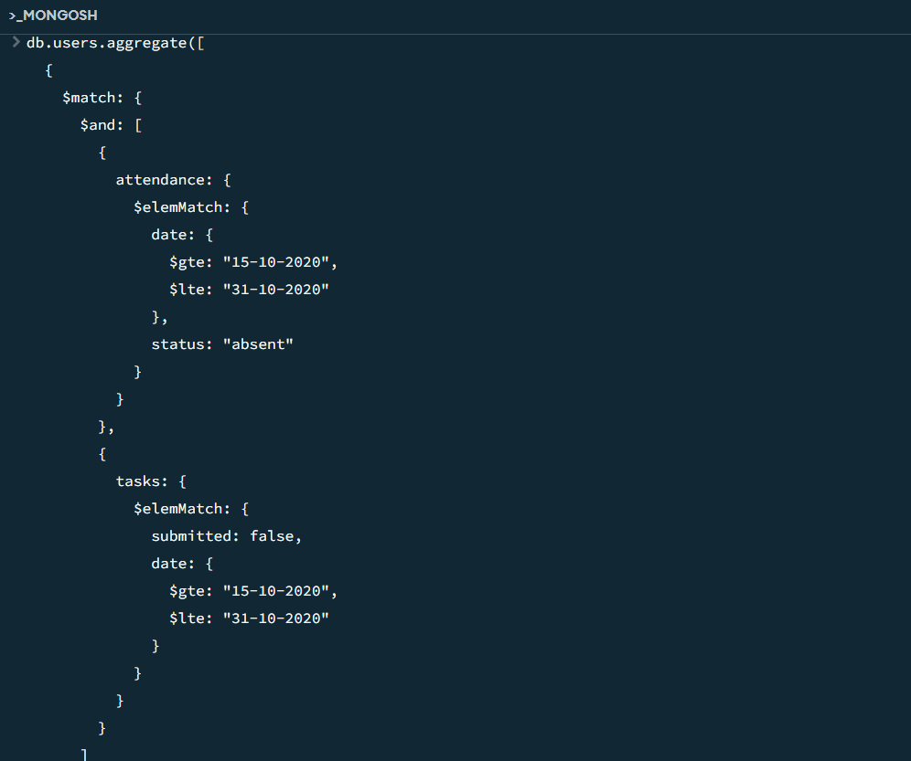

db.tasks.insertMany([

{task_id:1,task_name:"DB creation using mysql",date:"14-10-2020"},

{task_id:2,task_name:"Reverse engineering in mysql",date:"15-10-2020"},

{task_id:3,task_name:"write 10 queries based on questions",date:"17-10-2020"},

{tasl_id:4,task_name:"aggregation",date:"20-10-2020"}

]);

{

acknowledged: true,

insertedIds: {

'0': ObjectId('66928e8298045841a7d458b3'),

'1': ObjectId('66928e8298045841a7d458b4'),

'2': ObjectId('66928e8298045841a7d458b5'),

'3': ObjectId('66928e8298045841a7d458b6')

}

}

db.drives.insertMany([

{company_name:"ZohoCorp",date:"15-10-2020"},

{company_name:"Bosch",date:"20-10-2020"},

{company_name:"Accenture",date:"21-10-2020"},

{company_name:"TCS",date:"26-10-2020"},

{company_name:"Fresh Works",date:"29-10-2020"},

{company_name:"Amazon",date:"30-10-2020"}

]);

{

acknowledged: true,

insertedIds: {

'0': ObjectId('6692912198045841a7d458b7'),

'1': ObjectId('6692912198045841a7d458b8'),

'2': ObjectId('6692912198045841a7d458b9'),

'3': ObjectId('6692912198045841a7d458ba'),

'4': ObjectId('6692912198045841a7d458bb'),

'5': ObjectId('6692912198045841a7d458bc')

}

}

db.tasks.find();

{

_id: ObjectId('66928e8298045841a7d458b3'),

task_id: 1,

task_name: 'DB creation using mysql',

date: '14-10-2020'

}

{

_id: ObjectId('66928e8298045841a7d458b4'),

task_id: 2,

task_name: 'Reverse engineering in mysql',

date: '15-10-2020'

}

{

_id: ObjectId('66928e8298045841a7d458b5'),

task_id: 3,

task_name: 'write 10 queries based on questions',

date: '17-10-2020'

}

{

_id: ObjectId('66928e8298045841a7d458b6'),

tasl_id: 4,

task_name: 'aggregation',

date: '20-10-2020'

}

db.users.insertMany([

{

id:"FSD60WD1",

name:"Priyanka S",

codekata_solved:25,

attendance:[{date:"15-10-2024",status:"absent"},{ date: "16-10-2020", status: "present" },

{ date: "17-10-2020", status: "present" },{ date: "18-10-2020", status: "present" },

{ date: "19-10-2020", status: "present" },{ date: "20-10-2020", status: "present" },

{ date: "21-10-2020", status: "present" },{ date: "22-10-2020", status: "absent" },

{ date: "23-10-2020", status: "present" },{ date: "24-10-2020", status: "present" },

{ date: "25-10-2020", status: "present" },{ date: "26-10-2020", status: "present" },

{ date: "27-10-2020", status: "present" },{ date: "28-10-2020", status: "present" },

{ date: "29-10-2020", status: "present" },{ date: "30-10-2020", status: "present" }

],

tasks:[{task_id: ObjectId('66928e8298045841a7d458b3'),submitted:true,date:"16-10-2020"},

{task_id:ObjectId('66928e8298045841a7d458b4'),submitted:true,date:"20-10-2020"},

{task_id:ObjectId('66928e8298045841a7d458b5'),submitted:false},

{task_id:ObjectId('66928e8298045841a7d458b6'),submitted:true,date:"26-10-2020"}],

placement_drives:[ObjectId('6692912198045841a7d458b7'),ObjectId('6692912198045841a7d458b8'),ObjectId('6692912198045841a7d458b9')]

},

{

id:"FSD60WD2",

name:"Nandhini N",

codekata_solved:15,

attendance:[{date:"15-10-2024",status:"absent"},{ date: "16-10-2020", status: "present" },

{ date: "17-10-2020", status: "present" },{ date: "18-10-2020", status: "present" },

{ date: "19-10-2020", status: "present" },{ date: "20-10-2020", status: "present" },

{ date: "21-10-2020", status: "present" },{ date: "22-10-2020", status: "present" },

{ date: "23-10-2020", status: "present" },{ date: "24-10-2020", status: "present" },

{ date: "25-10-2020", status: "present" },{ date: "26-10-2020", status: "present" },

{ date: "27-10-2020", status: "present" },{ date: "28-10-2020", status: "present" },

{ date: "29-10-2020", status: "present" },{ date: "30-10-2020", status: "present" }

],

tasks:[{task_id:ObjectId('66928e8298045841a7d458b3'),submitted:true,date:"17-10-2020"},

{task_id: ObjectId('66928e8298045841a7d458b4'),submitted:false},

{task_id:ObjectId('66928e8298045841a7d458b5'),submitted:true,date:"20-10-2020"},

{task_id:ObjectId('66928e8298045841a7d458b6'),submitted:true,date:"23-10-2020"}],

placement_drives:[ObjectId('6692912198045841a7d458ba'),ObjectId('6692912198045841a7d458bb'),ObjectId('6692912198045841a7d458bc')]

}

]);

{

acknowledged: true,

insertedIds: {

'0': ObjectId('6692950498045841a7d458bd'),

'1': ObjectId('6692950498045841a7d458be')

}

}

db.find.users

task2.find.users

task2.find.users

ReferenceError: task2 is not defined

db.user.insertMany([

{

id:"FSD60WD1",

name:"Priyanka S",

codekata_solved:25,

attendance:[{date:"15-10-2024",status:"absent"},{ date: "16-10-2020", status: "present" },

{ date: "17-10-2020", status: "present" },{ date: "18-10-2020", status: "present" },

{ date: "19-10-2020", status: "present" },{ date: "20-10-2020", status: "present" },

{ date: "21-10-2020", status: "present" },{ date: "22-10-2020", status: "absent" },

{ date: "23-10-2020", status: "present" },{ date: "24-10-2020", status: "present" },

{ date: "25-10-2020", status: "present" },{ date: "26-10-2020", status: "present" },

{ date: "27-10-2020", status: "present" },{ date: "28-10-2020", status: "present" },

{ date: "29-10-2020", status: "present" },{ date: "30-10-2020", status: "present" }

],

tasks:[{task_id: ObjectId('66928e8298045841a7d458b3'),submitted:true,date:"16-10-2020"},

{task_id:ObjectId('66928e8298045841a7d458b4'),submitted:true,date:"20-10-2020"},

{task_id:ObjectId('66928e8298045841a7d458b5'),submitted:false},

{task_id:ObjectId('66928e8298045841a7d458b6'),submitted:true,date:"26-10-2020"}],

placement_drives:[ObjectId('6692912198045841a7d458b7'),ObjectId('6692912198045841a7d458b8'),ObjectId('6692912198045841a7d458b9')]

},

{

id:"FSD60WD2",

name:"Nandhini N",

codekata_solved:15,

attendance:[{date:"15-10-2024",status:"absent"},{ date: "16-10-2020", status: "present" },

{ date: "17-10-2020", status: "present" },{ date: "18-10-2020", status: "present" },

{ date: "19-10-2020", status: "present" },{ date: "20-10-2020", status: "present" },

{ date: "21-10-2020", status: "present" },{ date: "22-10-2020", status: "present" },

{ date: "23-10-2020", status: "present" },{ date: "24-10-2020", status: "present" },

{ date: "25-10-2020", status: "present" },{ date: "26-10-2020", status: "present" },

{ date: "27-10-2020", status: "present" },{ date: "28-10-2020", status: "present" },

{ date: "29-10-2020", status: "present" },{ date: "30-10-2020", status: "present" }

],

tasks:[{task_id:ObjectId('66928e8298045841a7d458b3'),submitted:true,date:"17-10-2020"},

{task_id: ObjectId('66928e8298045841a7d458b4'),submitted:false},

{task_id:ObjectId('66928e8298045841a7d458b5'),submitted:true,date:"20-10-2020"},

{task_id:ObjectId('66928e8298045841a7d458b6'),submitted:true,date:"23-10-2020"}],

placement_drives:[ObjectId('6692912198045841a7d458ba'),ObjectId('6692912198045841a7d458bb'),ObjectId('6692912198045841a7d458bc')]

}

]);

{

acknowledged: true,

insertedIds: {

'0': ObjectId('6692953e98045841a7d458bf'),

'1': ObjectId('6692953e98045841a7d458c0')

}

}

db.users.find();

{

_id: ObjectId('6692888798045841a7d458b1')

}

{

_id: ObjectId('669288d198045841a7d458b2'),

id: 'FSD60WD1',

name: 'Priyanka S'

}

{

status: 'present'

},

{

date: '26-10-2020',

status: 'present'

},

{

date: '27-10-2020',

status: 'present'

},

{

date: '28-10-2020',

status: 'present'

},

{

date: '29-10-2020',

status: 'present'

},

{

date: '30-10-2020',

status: 'present'

}

],

tasks: [

{

task_id: ObjectId('66928e8298045841a7d458b3'),

submitted: true,

date: '16-10-2020'

},

{

task_id: ObjectId('66928e8298045841a7d458b4'),

submitted: true,

date: '20-10-2020'

},

{

task_id: ObjectId('66928e8298045841a7d458b5'),

submitted: false

},

{

task_id: ObjectId('66928e8298045841a7d458b6'),

submitted: true,

date: '26-10-2020'

}

],

placement_drives: [

ObjectId('6692912198045841a7d458b7'),

ObjectId('6692912198045841a7d458b8'),

ObjectId('6692912198045841a7d458b9')

]

}

{

},

{

date: '21-10-2020',

status: 'present'

},

{

date: '22-10-2020',

status: 'present'

},

{

date: '23-10-2020',

status: 'present'

},

{

date: '24-10-2020',

status: 'present'

},

{

date: '25-10-2020',

status: 'present'

},

{

date: '26-10-2020',

status: 'present'

},

{

date: '27-10-2020',

status: 'present'

},

{

date: '28-10-2020',

status: 'present'

},

{

date: '29-10-2020',

status: 'present'

},

{

date: '30-10-2020',

status: 'present'

}

],

tasks: [

{

task_id: ObjectId('66928e8298045841a7d458b3'),

submitted: true,

date: '17-10-2020'

},

{

task_id: ObjectId('66928e8298045841a7d458b4'),

submitted: false

},

{

task_id: ObjectId('66928e8298045841a7d458b5'),

submitted: true,

date: '20-10-2020'

},

{

task_id: ObjectId('66928e8298045841a7d458b6'),

submitted: true,

date: '23-10-2020'

}

],

placement_drives: [

ObjectId('6692912198045841a7d458ba'),

ObjectId('6692912198045841a7d458bb'),

ObjectId('6692912198045841a7d458bc')

]

}

db.user.drop();

true

db.users.find();

{

_id: ObjectId('6692888798045841a7d458b1')

}

{

_id: ObjectId('669288d198045841a7d458b2'),

id: 'FSD60WD1',

name: 'Priyanka S'

}

_id: ObjectId('6692950498045841a7d458bd'),

},

{

date: '26-10-2020',

status: 'present'

},

{

date: '27-10-2020',

status: 'present'

},

{

date: '28-10-2020',

status: 'present'

},

{

date: '29-10-2020',

status: 'present'

},

{

date: '30-10-2020',

status: 'present'

}

],

tasks: [

{

task_id: ObjectId('66928e8298045841a7d458b3'),

submitted: true,

date: '16-10-2020'

},

{

task_id: ObjectId('66928e8298045841a7d458b4'),

submitted: true,

date: '20-10-2020'

},

{

task_id: ObjectId('66928e8298045841a7d458b5'),

submitted: false

},

{

task_id: ObjectId('66928e8298045841a7d458b6'),

submitted: true,

date: '26-10-2020'

}

],

placement_drives: [

ObjectId('6692912198045841a7d458b7'),

ObjectId('6692912198045841a7d458b8'),

ObjectId('6692912198045841a7d458b9')

]

}

status: 'present'

{

date: '25-10-2020',

status: 'present'

},

{

date: '26-10-2020',

status: 'present'

},

{

date: '27-10-2020',

status: 'present'

},

{

date: '28-10-2020',

status: 'present'

},

{

date: '29-10-2020',

status: 'present'

},

{

date: '30-10-2020',

status: 'present'

}

],

tasks: [

{

task_id: ObjectId('66928e8298045841a7d458b3'),

submitted: true,

date: '17-10-2020'

},

{

task_id: ObjectId('66928e8298045841a7d458b4'),

submitted: false

},

{

task_id: ObjectId('66928e8298045841a7d458b5'),

submitted: true,

date: '20-10-2020'

},

{

task_id: ObjectId('66928e8298045841a7d458b6'),

submitted: true,

date: '23-10-2020'

}

],

placement_drives: [

ObjectId('6692912198045841a7d458ba'),

ObjectId('6692912198045841a7d458bb'),

ObjectId('6692912198045841a7d458bc')

]

}

db.codekata.insertMany([{user_id: ObjectId('6692950498045841a7d458bd'),problems_solved:25},

{user_id:ObjectId('6692950498045841a7d458be'),problems_solved:15}]);

{

acknowledged: true,

insertedIds: {

'0': ObjectId('669296ff98045841a7d458c1'),

'1': ObjectId('669296ff98045841a7d458c2')

}

}

db.topics.insertMany([{topic_name:"Intro to mysql",date:"15-10-2020"},

{topic_name: "Mysql queries", date: "16-10-2020"},

{topic_name: "MongoDB", date: "18-10-2020"},

{topic_name: "Advanced MongoDB", date: "20-10-2020"}]);

{

acknowledged: true,

insertedIds: {

'0': ObjectId('669297d698045841a7d458c3'),

'1': ObjectId('669297d698045841a7d458c4'),

'2': ObjectId('669297d698045841a7d458c5'),

'3': ObjectId('669297d698045841a7d458c6')

}

}

db.mentors.insertMany([{mentor_name:"Jhon",mentees:10},

{mentor_name:"Balamurugan",mentees:20}]);

{

acknowledged: true,

insertedIds: {

'0': ObjectId('669298dc98045841a7d458c7'),

'1': ObjectId('669298dc98045841a7d458c8')

}

}

db.topics.find({

date:{$regex:".*-10-2020"}});

{

_id: ObjectId('669297d698045841a7d458c3'),

topic_name: 'Intro to mysql',

date: '15-10-2020'

}

{

_id: ObjectId('669297d698045841a7d458c4'),

topic_name: 'Mysql queries',

date: '16-10-2020'

}

{

_id: ObjectId('669297d698045841a7d458c5'),

topic_name: 'MongoDB',

date: '18-10-2020'

}

{

_id: ObjectId('669297d698045841a7d458c6'),

topic_name: 'Advanced MongoDB',

date: '20-10-2020'

}

db.tasks.find({

date: { $regex: ".*-10-2020" }

});

{

_id: ObjectId('66928e8298045841a7d458b3'),

task_id: 1,

task_name: 'DB creation using mysql',

date: '14-10-2020'

}

{

_id: ObjectId('66928e8298045841a7d458b4'),

task_id: 2,

task_name: 'Reverse engineering in mysql',

date: '15-10-2020'

}

{

_id: ObjectId('66928e8298045841a7d458b5'),

task_id: 3,

task_name: 'write 10 queries based on questions',

date: '17-10-2020'

}

{

_id: ObjectId('66928e8298045841a7d458b6'),

tasl_id: 4,

task_name: 'aggregation',

date: '20-10-2020'

}

db.drives.find({

date: { $gte: "15-10-2020", $lte: "31-10-2020" }

});

{

_id: ObjectId('6692912198045841a7d458b7'),

company_name: 'ZohoCorp',

date: '15-10-2020'

}

{

_id: ObjectId('6692912198045841a7d458b8'),

company_name: 'Bosch',

date: '20-10-2020'

}

{

_id: ObjectId('6692912198045841a7d458b9'),

company_name: 'Accenture',

date: '21-10-2020'

}

{

_id: ObjectId('6692912198045841a7d458ba'),

company_name: 'TCS',

date: '26-10-2020'

}

{

_id: ObjectId('6692912198045841a7d458bb'),

company_name: 'Fresh Works',

date: '29-10-2020'

}

{

_id: ObjectId('6692912198045841a7d458bc'),

company_name: 'Amazon',

date: '30-10-2020'

}

db.company_drives.aggregate([

{

$lookup: {

from: "users",

localField: "_id",

foreignField: "placement_drives",

as: "students"

}

}

]);

db.users.aggregate([{

$lookup:{

from:"drives",

localFeild:"placement_drives",

foreignFeild:"_id",

as:"placement_drives_info"

}},

{

$project:{

name:1,

placement_drives:"$placement_drive_info.company_name"

}

}

}]);

SyntaxError: Unexpected token, expected "," (14:0)

12 | }

13 | }

> 14 | }]);

| ^

db.users.aggregate([{

$lookup:{

from:"drives",

localFeild:"placement_drives",

foreignFeild:"_id",

as:"placement_drives_info"

}},

{

$project:{

name:1,

placement_drives:"$placement_drive_info.company_name"

}

}]);

MongoServerError[FailedToParse]: unknown argument to $lookup: localFeild

db.users.aggregate([{

$lookup:{

from:"drives",

localField:"placement_drives",

foreignField:"_id",

as:"placement_drives_info"

}},

{

$project:{

name:1,

placement_drives:"$placement_drive_info.company_name"

}

}]);

{

_id: ObjectId('6692950498045841a7d458bd'),

name: 'Priyanka S'

}

{

_id: ObjectId('6692950498045841a7d458be'),

name: 'Nandhini N'

}

db.users.aggregate([

{

$lookup: {

from: "drives",

localField: "placement_drives",

foreignField: "_id",

as: "placement_drives_info"

}

},

{

$project: {

name: 1,

placement_drives: "$placement_drives_info.company_name"

}

},

{

$unwind: "$placement_drives"

}

]);

{

_id: ObjectId('6692950498045841a7d458bd'),

name: 'Priyanka S',

placement_drives: 'Accenture'

}

{

_id: ObjectId('6692950498045841a7d458bd'),

name: 'Priyanka S',

placement_drives: 'ZohoCorp'

}

{

_id: ObjectId('6692950498045841a7d458bd'),

name: 'Priyanka S',

placement_drives: 'Bosch'

}

{

_id: ObjectId('6692950498045841a7d458be'),

name: 'Nandhini N',

placement_drives: 'Amazon'

}

{

_id: ObjectId('6692950498045841a7d458be'),

name: 'Nandhini N',

placement_drives: 'TCS'

}

{

_id: ObjectId('6692950498045841a7d458be'),

name: 'Nandhini N',

placement_drives: 'Fresh Works'

}

db.codekata.aggregate([

{$group:{_id:null,total_problems_solved:{"problems_solved"}}}]);

SyntaxError: Unexpected token (2:60)

1 | db.codekata.aggregate([

> 2 | {$group:{_id:null,total_problems_solved:{"problems_solved"}}}]);

| ^

db.codekata.aggregate([

{$group:{_id:null,total_problems_solved:{$sum:"problems_solved"}}}]);

{

_id: null,

total_problems_solved: 0

}

db.users.aggregate([

{

$lookup: {

from: "codekata",

localField: "_id",

foreignField: "user_id",

as: "codekata_info"

}

},

{

$project: {

name: 1,

problems_solved: { $sum: "$codekata_info.problems_solved" }

}

}

]);

{

_id: ObjectId('6692950498045841a7d458bd'),

name: 'Priyanka S',

problems_solved: 25

}

{

_id: ObjectId('6692950498045841a7d458be'),

name: 'Nandhini N',

problems_solved: 15

}

db.mentors.aggregate([

{

$lookup: {

from: "mentees",

localField: "mentor_id",

foreignField: "mentor_id",

as: "mentees"

}

},

{

$group: {

_id: "$mentor_name",

num_mentees: { $sum: { $size: "$mentees" } }

}

},

{

$match: {

num_mentees: { $gt: 15 }

}

}

]);

db.mentors.find([mentees{$gt:15}

]);

SyntaxError: Unexpected token, expected "," (1:24)

> 1 | db.mentors.find([mentees{$gt:15}

| ^

2 | ]);

3 |

db.mentors.find([mentees:{$gt:15}

]);

SyntaxError: Unexpected token, expected "," (1:24)

> 1 | db.mentors.find([mentees:{$gt:15}

| ^

2 | ]);

3 |

db.mentors.find({ mentees: { $gt: 15 } });

{

_id: ObjectId('669298dc98045841a7d458c8'),

mentor_name: 'Balamurugan',

mentees: 20

}

db.users.aggregate([

{

$match: {

attendance: {

$elemMatch: {

date: {

$gte: "15-10-2020",

$lte: "31-10-2020"

},

status: "absent"

}

},

tasks: {

$elemMatch: {

submitted: false,

date: {

$gte: "15-10-2020",

$lte: "31-10-2020"

}

}

}

}

},

{

$count: "users_count"

}

]);

db.users.aggregate([

{

$match: {

$and: [

{

attendance: {

$elemMatch: {

date: {

$gte: "15-10-2020",

$lte: "31-10-2020"

},

status: "absent"

}

}

},

{

tasks: {

$elemMatch: {

submitted: false,

date: {

$gte: "15-10-2020",

$lte: "31-10-2020"

}

}

}

}

]

}

},

{

$count: "users_count"

}

]);